**DAILY ONLINE ACTIVITIES SUMMARY**

|  |  |  |  |  |  |  |  |  |
| --- | --- | --- | --- | --- | --- | --- | --- | --- |
| **Date:** | **05-06-2020** | | | | | **Name:** | **Anix Jugal D’Cunha** | |
| **Sem & Sec** | **8 sem , A sec** | | | | | **USN:** | **4al16cs013** | |
| **Online Test Summary** | | | | | | | | |
| **Subject** | | **BDA** | | | | | | |
| **Max. Marks** | | **30** | | **Score** | | | **15** | |
| **Certification Course Summary** | | | | | | | | |
| **Course** | **The Data Science Certification Course** | | | | | | | |
| **Certificate Provider** | | | **Udemy** | | **Duration** | | | **40 mins** |
| **Coding Challenges** | | | | | | | | |
| **Problem Statement:**  Write a Python program to convert seconds today, hour, minutes and seconds | | | | | | | | |
| **Status: Completed** | | | | | | | | |
| **Uploaded the report in Github** | | | | | **yes** | | | |
| **If yes Repository name** | | | | | **alvas-education-foundation/dcunhaanixjugal** | | | |
| **Uploaded the report in slack** | | | | | **yes** | | | |

Online Test Details: (Attach the snapshot and briefly write the report for the same)

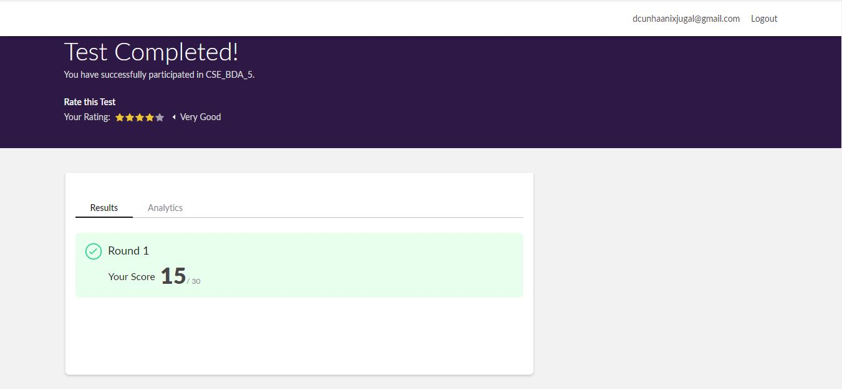

Certification Course Details: (Attach the snapshot and briefly write the report for the same)

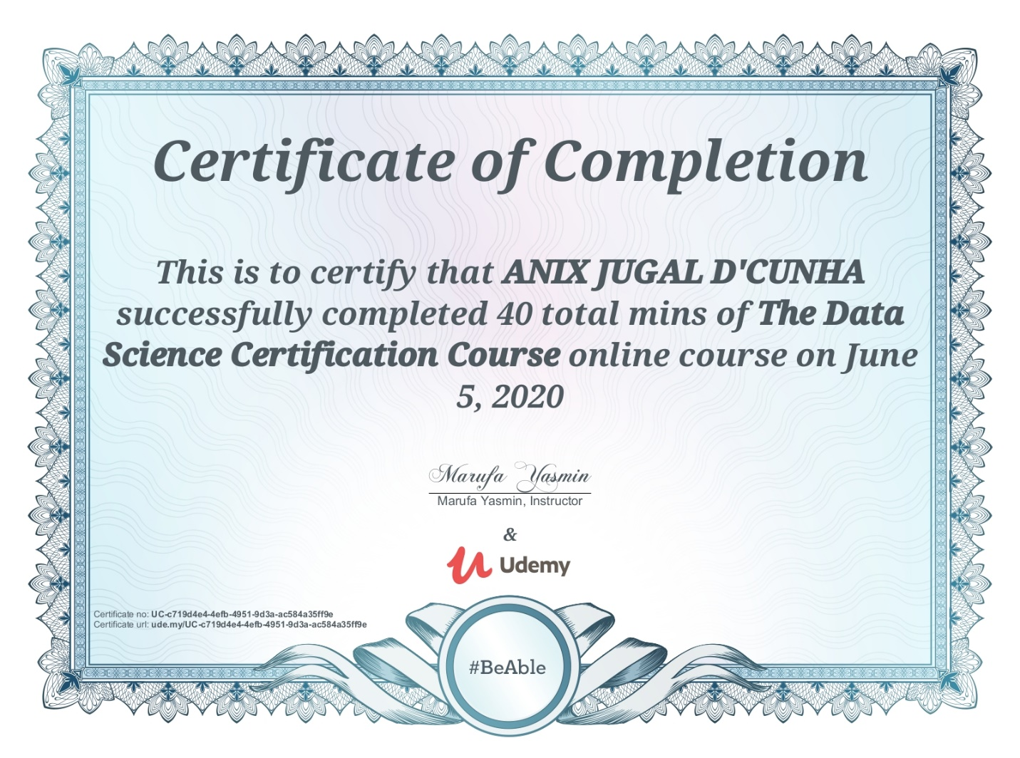

Coding Challenges Details: (Attach the snapshot and briefly write the report for the same)

Program -> Write a Python program to convert seconds today, hour, minutes and seconds

time=float(input("Input time in seconds:"))

day=time

//(24*3600) time=time%(24*3600)

hour=time//3600

time%=3600

minutes=time

//60 time%=60

seconds=time print("day:->%d"%(day))

print("hour:->%d"%(hour))

print("minutes:->%d"%(minutes))

print("seconds:->%d"%(seconds))